# **Tech task—Time and space complexity**

**1.Find the time and space complexity for the following code and explain.**

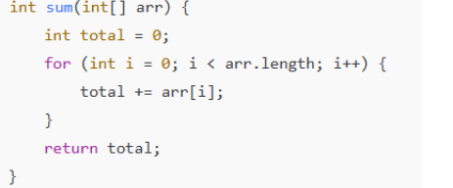

**Time complexity: O(n)**

**Explanation:** The program is trying to find the total of the elements in the array. So, it loops through the array length and find the element and adds it to the total until the nth element is reached. Therefore, it has the specified time- complexity.

**Space complexity: O (1)**

**Explanation:** The program is trying to find the total of the elements in the array. It loops till the last element of the array. But here the extra variable is total and loop variable “i” which is initialized as zero and gets updated through the loop. It does not create any new data structures for the outcome. Therefore, due to one extra variable it has the following space complexity.

**2. Determine time and space complexity**

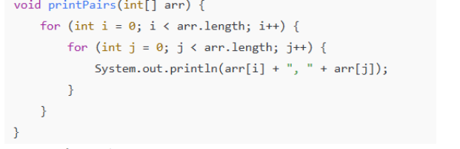

**Time complexity :O(n2)**

**Explanation:**

Here the program is aiming to create a two-dimensional array ana wanted them to display in pairs. There are two loops totally and therefore the time complexity is O(n2).

**Space Complexity: O (1)**

**Explanation:**

Here the space complexity Is order (1) because it uses only loop variables except the input and therefore it is very simple and have basic space complexity.

**3. Recursive factorial**

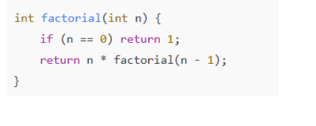

**Time complexity :O (n)**

**Explanation:**

The program is aiming to find the factorial of the given number. This is a recursive type program and it is used to implement the outcome through recursive calls. Here it uses one value per call hence have the time complexity as Order (1).

**Space Complexity: O(n)**

**Explanation:**

This follows stack data structure which implements FIFO (First in first out methods). So, only one frame of stack is there in one call and hence it uses the Order(n) space complexity.